**EX 13 : Project Report**

Developed the front end for our project **SpendTrack** using react js . Database is done using MySQL workbench. The front end and the database is linked using Fast API.

We have created an user interactive front end that has features like login , signup , edit profile , add expense , set budget , add friends , see recent transactions , etc . The app also display interactive charts to visualize the spending patterns among various categories and within the month. It also contains feature to create group , add friends to it and split expense among our friends . The splitted amount will be automatically added to the friends database.

The sync bank transactions which automatically syncs the user transactions from the bank account and AI suggestions features are not yet been added since it requires paid API to use. The database tables are created , only the front end part is not done .

This app is now ready to use to public with these features.

Here are some images of the interactive front end of our project along with database pictures.

Login Page

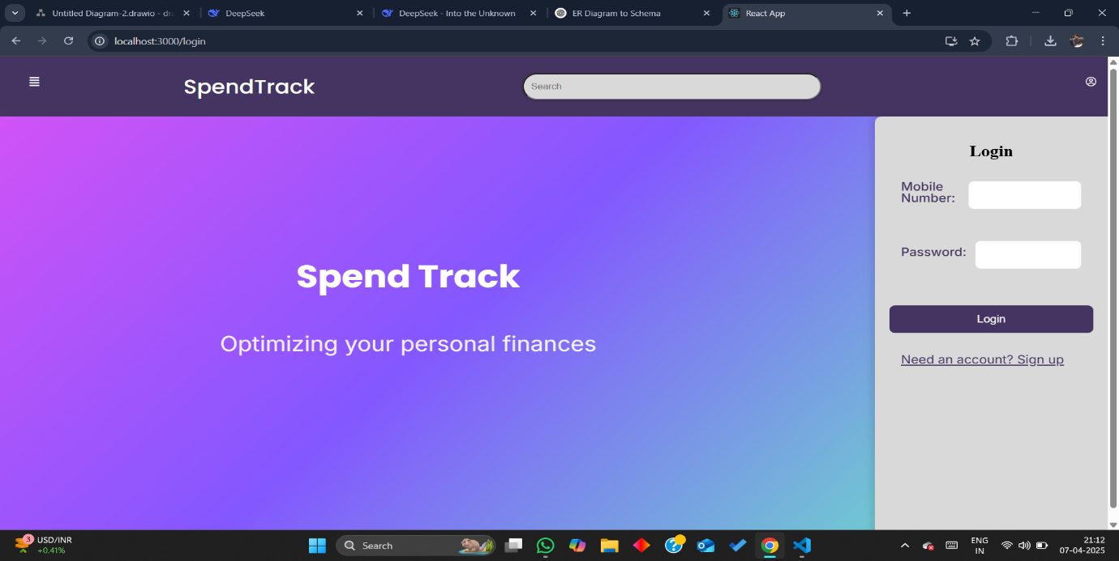

Sign Up Page

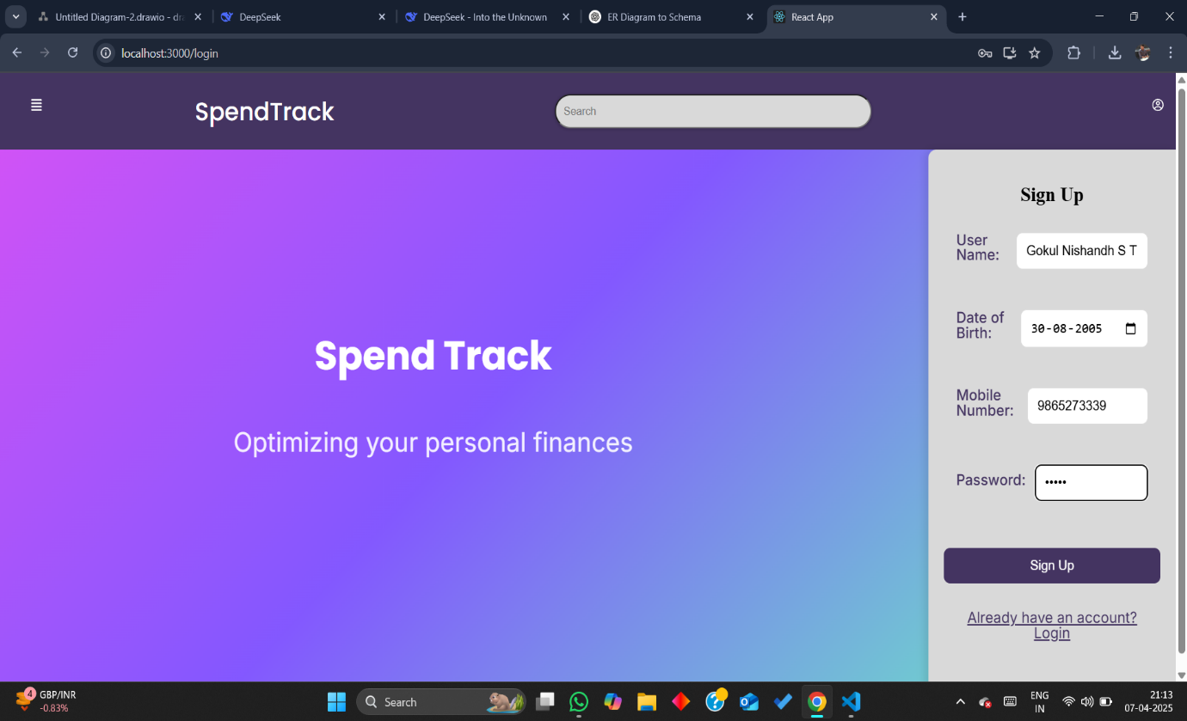

Profile bar

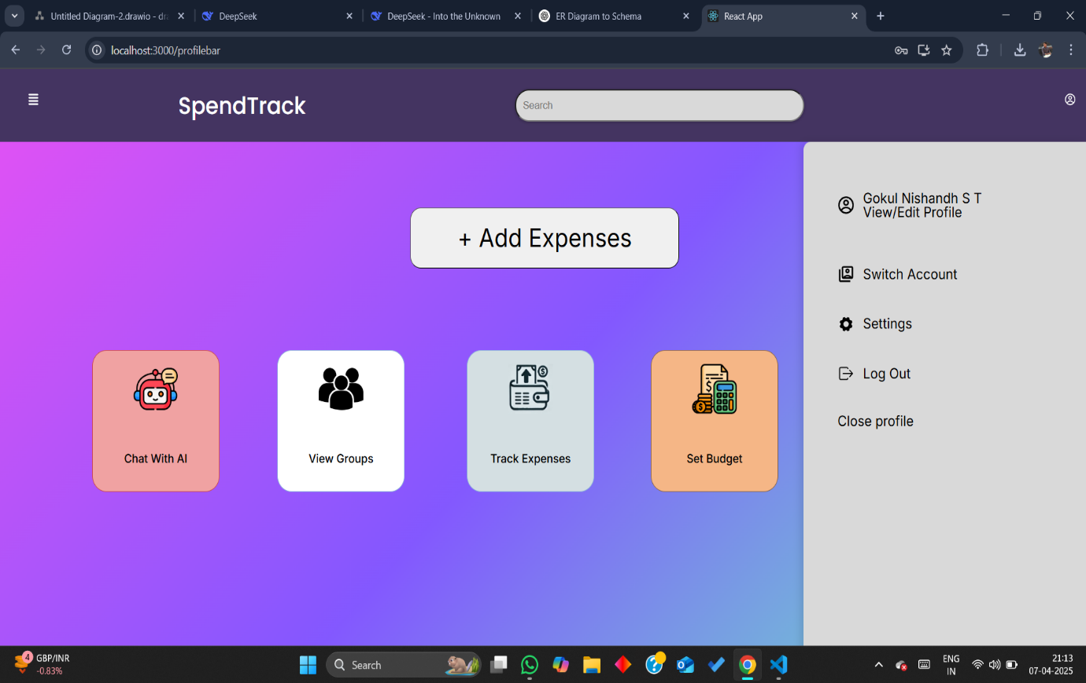

View Profile

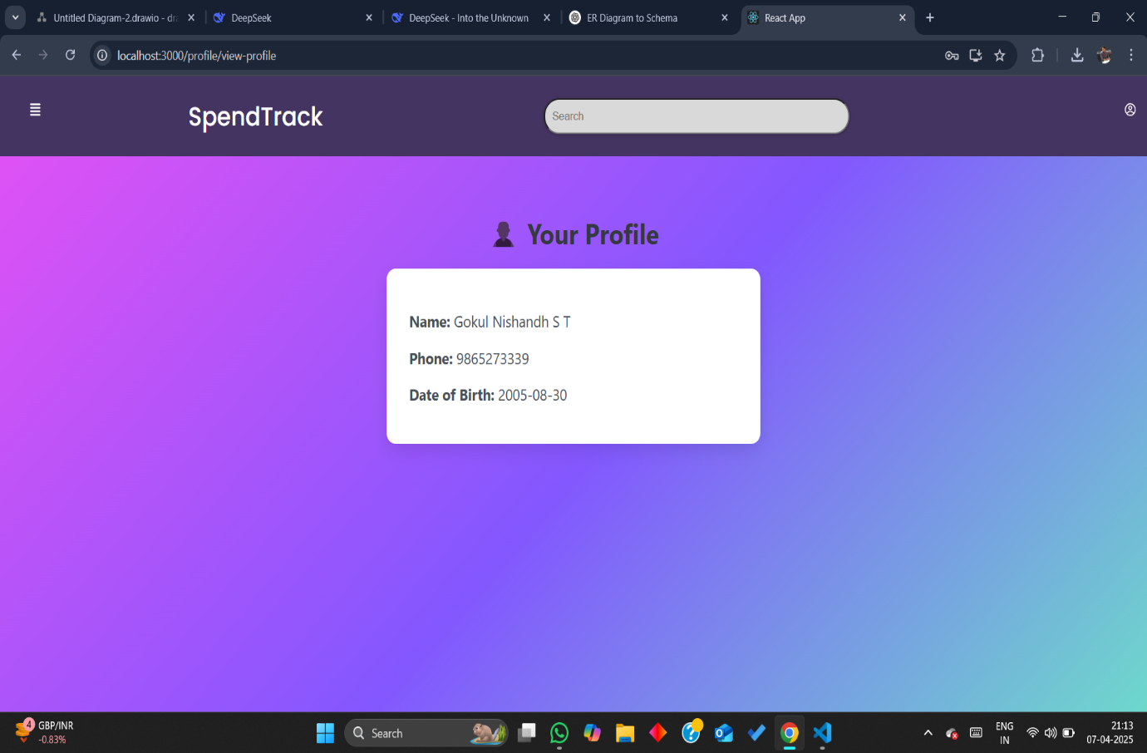

Add Expense

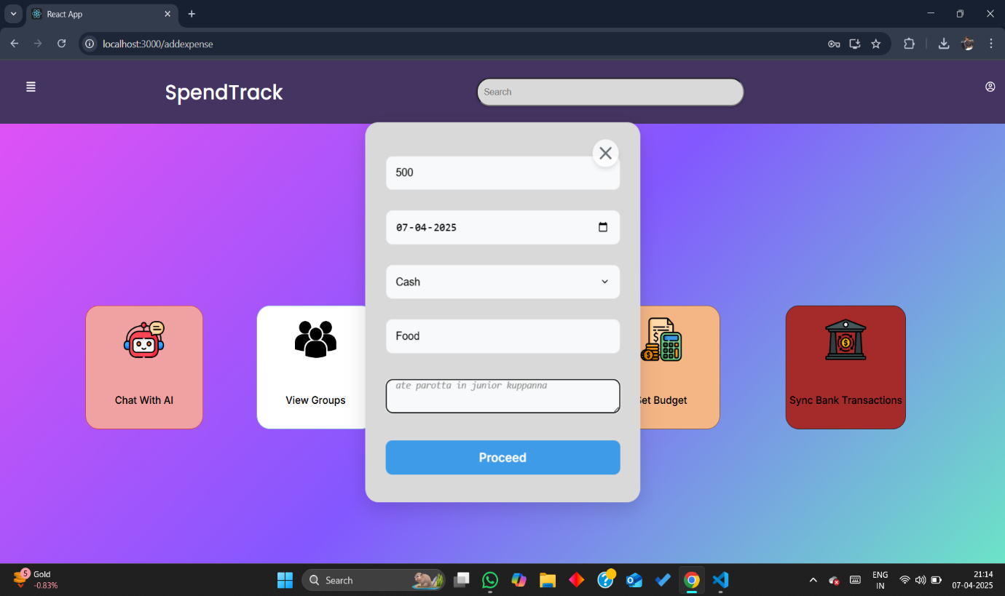

Set Budget Page

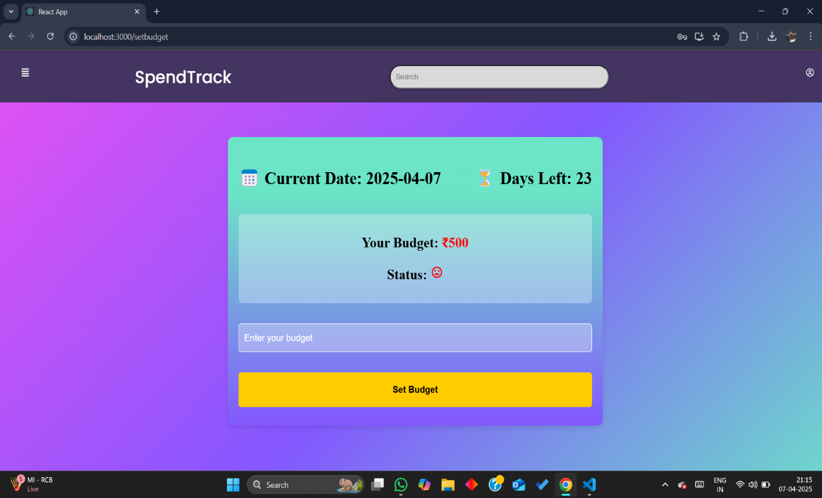

Track Expense

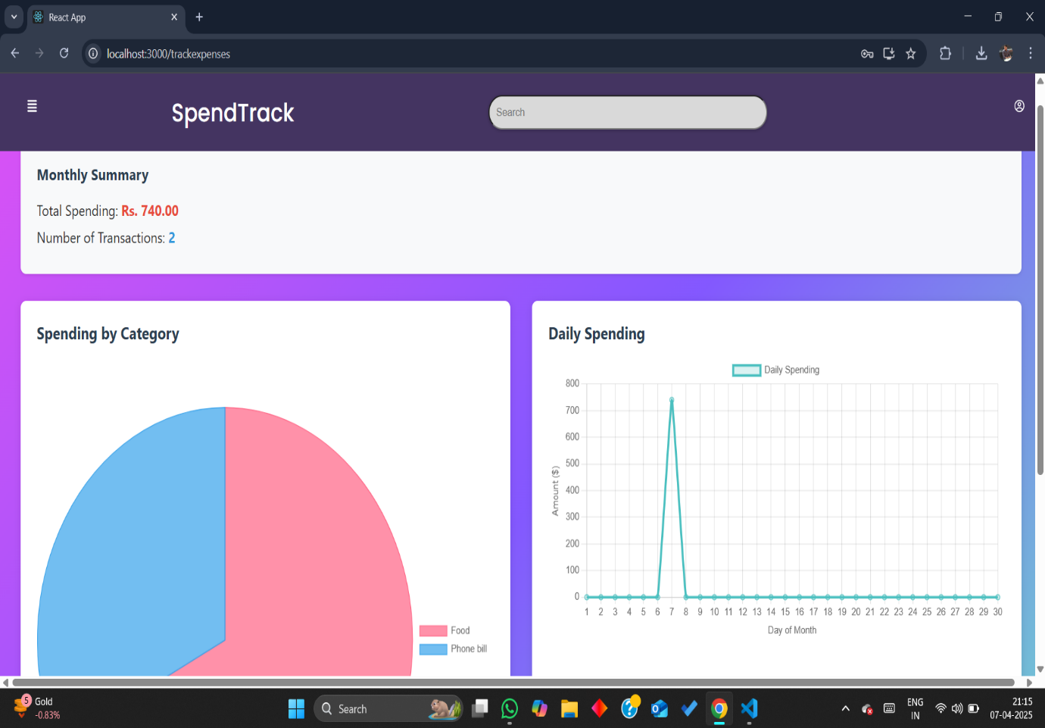

Add Friends

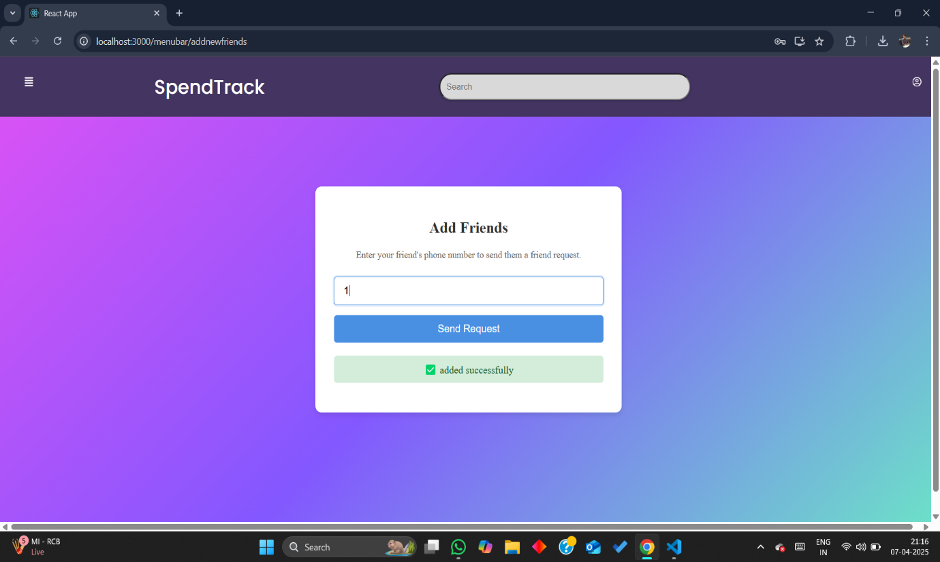

Create Group

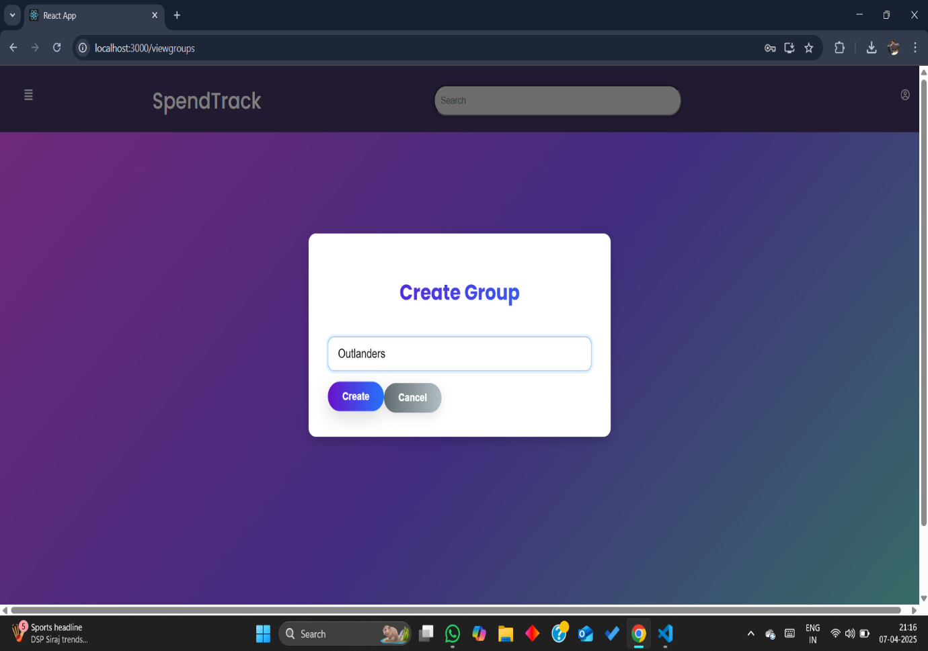

Add Friends To the Group

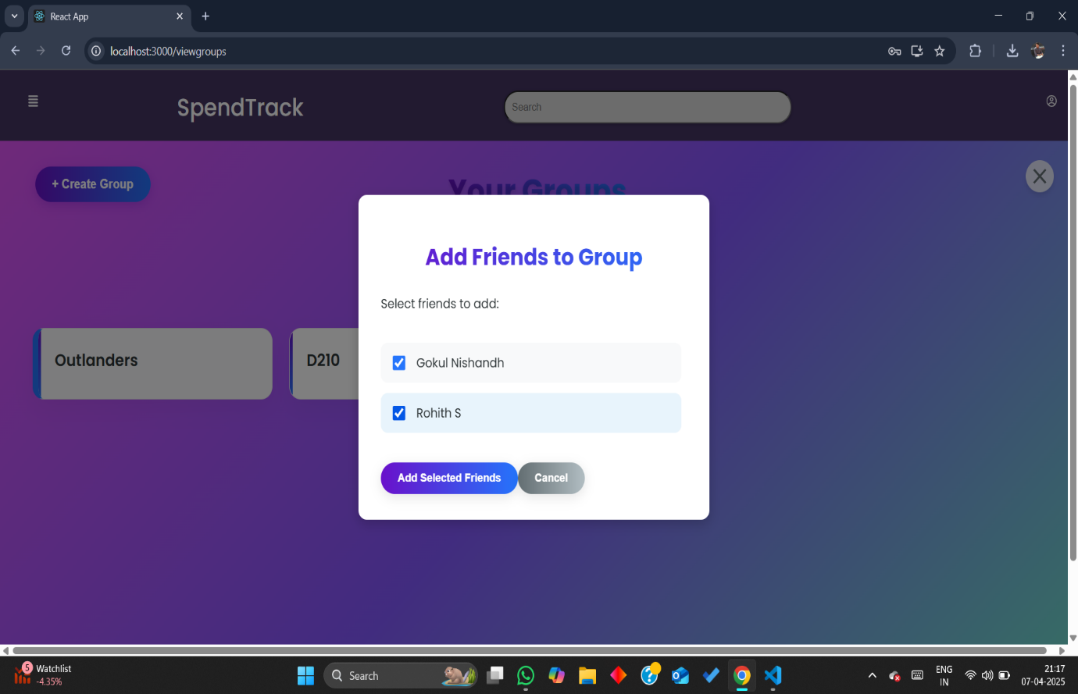

Split the expense within group

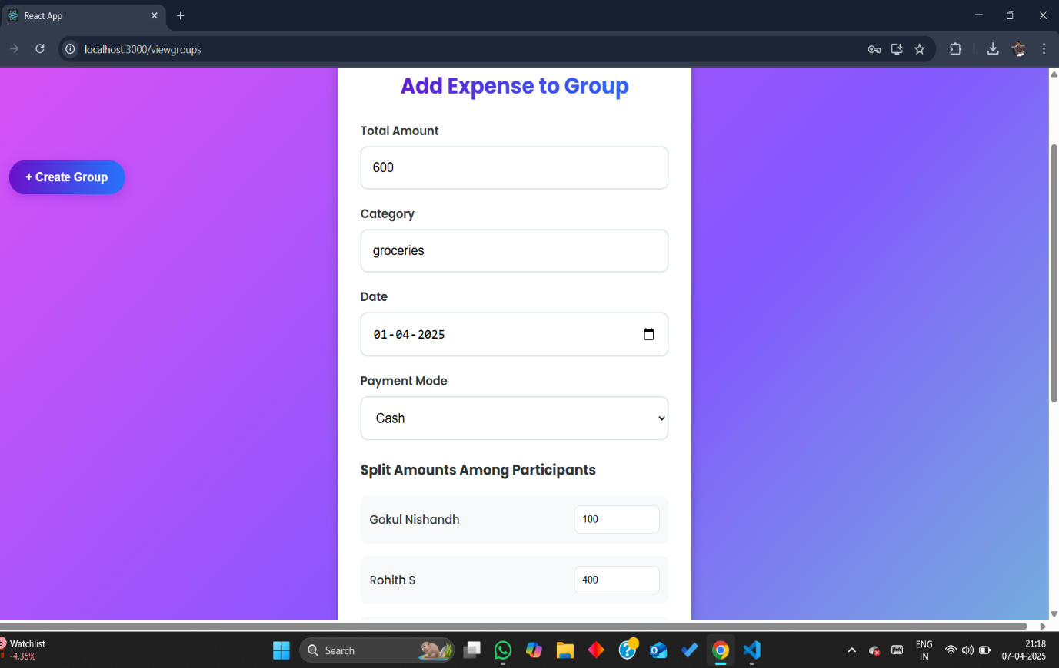

Recent Transactions